Type your title here using 11-point Times New Roman bold font on 12-point line spacing.
The length of the title of the article must not exceed 2 lines.

Author Names (Use 10-point Times New Roman font on 11-point line spacing.
Begin with the first name of the author followed by the last name. For more than one author, type ‘and’ before the last author’s name. For more than two authors, also separate each name by a comma (,). Identify each author’s affiliation by superscript numbers at the end of the author’s last name.)

Author Affiliations (Use 9-point Times New Roman font on 10-point line spacing.
Include institutional and e-mail addresses for all authors. Authors with the same affiliation must use the same numbering. Place superscript number in front of author’s affiliation corresponding to author’s name.)

*Corresponding author; E-mail

EXAMPLE for Authors and affiliations All authors must provide ORCID NO:
Kanda Wongwai¹,*, ORCID: 0000-0002-XXXX-XXXX
Johnette A. Smithson², ORCID: 0000-0001-XXXX-XXXX
Mariiea Chen³, ORCID: 0000-0003-XXXX-XXXX
¹ Collage of Engineering, Rangsit University, Pathum Thani 12000, Thailand
² Department of Computer Science, ABC University, New York, USA
³ School of Science, XYZ University, Beijing, China
*Corresponding author: Email: kanda.w@rsu.ac.th
Received date month, year; Revised date month, year; Accepted (To be completed by JCST)
Published online date month year (To be completed by JCST)

____________________________________________________________________________________________________________

Abstract (10-point bold font on 11-point line spacing)
This template is intended for review articles and is limited to systematic reviews only. JCST will not consider narrative reviews that do not provide a clear methodology for screening and selecting source articles.For the abstract, use 9-point Times New Roman font with 11-point line spacing. The first line should be indented 0.5 inch. An abstract of up to 300 words must be included. The abstract should be written as a single paragraph, as preferred by JCST. It should clearly present the problem statement, objectives of the paper, brief methodology, major findings, academic contribution, and significance of the findings in a concise and useful manner. For the methodology, authors should briefly describe how the study was conducted, including the study design, materials or data sources, analytical methods, and any major procedures used, where applicable.

Keywords: List up to 7 keywords and separate each keyword by a comma (,) in lower case letters and in alphabetical order. The keywords should accurately reflect the content of the article. The keywords will be used for indexing purposes.
________________________________________________________________________________________________

1. Introduction
The manuscript must be prepared using the single-column JCST template. Accepted manuscripts will be formatted into the double-column layout by the JCST editorial staff. This single-column format is used to make manuscript preparation and review more convenient for authors, reviewers, and editors.
The manuscript should be typed in 10-point Times New Roman font with 12-point line spacing. Page margins should be set as follows: 1.25 inches on the left, 1 inch on the right and bottom, and 2 inches at the top. The header should be 1.0 inch and the footer 0.6 inch. The first line of each paragraph should be indented 0.5 inch. The paper size must be A4, approximately 8.27 × 11.69 inches.
The Introduction should place the research topic in a broader context and be understandable to readers who may not be specialists in the field. It should briefly review relevant and up-to-date literature, identify the research gap, and explain the importance of the study. For a review article, the Introduction must clearly state the value and usefulness of the review, such as how it synthesizes existing knowledge, clarifies current limitations, identifies research trends, supports future studies, or provides practical implications. If there are relevant controversies, limitations, or disagreements in the field, these should be briefly mentioned. The Introduction should end with a clear statement of the study objective or overall aim.

1.1 Type of review article for JCST
JCST may consider two types of review articles: systematic review articles and critical narrative review articles. Systematic reviews must include a reproducible methodology, including review design, search strategy, eligibility criteria, study selection, data extraction, quality assessment, and data synthesis. Critical narrative reviews may be accepted only when they provide an advanced, current, and novel synthesis of the literature. Purely descriptive or textbook-style narrative reviews without a clear review methodology, research gap, and future perspective are not suitable for publication in JCST.

1.1.1 Systematic Review Article
This type is suitable when the article answers a clearly defined research question using a reproducible search and selection process.
Suggested subtitles
- Introduction
- Objective(s)
- Review Methodology
3.1 Review Design, (PRISMA flow diagram is preferred).
3.2 Search Strategy
3.3 Eligibility Criteria
3.4 Study Selection
3.5 Data Extraction and Quality Assessment
3.6 Data Synthesis
- Results
- Discussion
- Limitations
- Conclusion
Best for: evidence-based review, health science, engineering applications, environmental studies, intervention studies, material performance comparison, or topics with many comparable studies.

1.1.2. Critical Narrative Review Article
This type is suitable when the article provides an advanced, critical, and novel synthesis of current knowledge, but does not follow a full systematic review process.
Suggested subtitles
- Introduction
- Objective(s)
- Review Methodology (Provide flow diagram)
- Current Knowledge and Applications
- Challenges and Research Gaps
- Future Perspectives
- Conclusion
Best for: emerging technologies, theoretical development, novel applications, conceptual frameworks, mechanism-based discussion, or interdisciplinary topics.

1.2 Format of components
1.2.1 Mathematical Equations
The mathematical equations must be typed the Equation Editor (Math Equations tool). Equations inserted as images or plain text are not acceptable. For example,
For example, equations should be formatted using the Equation Editor as follows:
$$F=ma \\ E=mc^{2} \\ \text{Accuracy}=\frac{TP+TN}{TP+TN+FP+FN}$$
JCST will decline manuscripts in which equations are typed as plain text in MS Word, as this causes difficulties during publication formatting and typesetting.

1.2.2 Citation for review article
Review articles submitted to JCST are strongly expected to present advanced knowledge, novelty, or novel applications in the relevant field. Therefore, JCST pays particular attention to the currency of the references. The majority of cited references should be recent and preferably published within the last five years. Older references may be used only when they are essential, such as for foundational theories, standard methods, historical background, or landmark studies.JCST uses the author–year citation system. In-text citations must include the author’s last name and the year of publication. There are two main forms of citation: narrative citation and parenthetical citation.
- Citation at the beginning
A narrative citation is used when the author’s name is part of the sentence; in this form, the year is placed in parentheses after the author’s name. For example, use “Sukjaidee (2020) reported that ...” for one author, “Yuangnun and Krukimsom (2020) found that ...” for two authors, and “Yuangnun et al. (2023) demonstrated that ...” for three or more authors.
- Citation at the end or the middle
A parenthetical citation is used when the author’s name and year are placed together in parentheses, usually at the end of the relevant statement. For example, use “... as previously reported (Sukjaidee, 2020)” for one author, “... as previously reported (Yuangnun & Krukimsom, 2020)” for two authors, and “... as previously reported (Yuangnun et al., 2023)” for three or more authors. Authors must ensure that every in-text citation appears in the reference list and that every reference in the reference list is cited in the manuscript. This is the example for middle citation: … sport viewed as a spiritual path (Leskowitz, 2017), and one that is frequently followed in the west.

All references cited in the manuscript must appear in the reference list, and all references in the reference list must be cited in the text. The reference list should be arranged alphabetically by the first author’s last name. Authors must carefully check that author names, publication years, and citation details are consistent between the text and the reference list. The use of recent and relevant references is strongly recommended. A reference may be cited as “in press” only if it has been formally accepted for publication. Authors are fully responsible for the accuracy and completeness of all citations and references. For example:
While other positive psychology constructs (e.g., resilience, hope, core self-evaluations, social support) have been studied in people with MS (Alschuler et al., 2018; Arewasikporn et al., 2018; Farber et al., 2015; Lee et al., 2020; Lynch et al., 2001; Madan & Pakenham, 2014), there is a dearth of research examining grit in this population.

2. Objectives
The objectives of a review article must be stated clearly, explicitly, and in a measurable manner. They should indicate what the review aims to examine, compare, synthesize, evaluate, or identify. Authors should ensure that the stated objectives are directly aligned with the Results and Discussion sections, as reviewers will assess whether the manuscript adequately addresses each objective. The objectives may be written either as a single concise paragraph or as a numbered list. For review articles, acceptable objectives may include identifying current knowledge, comparing findings across studies, evaluating methodological or technological developments, identifying research gaps, and proposing future research directions.

3. Review Methodology
This section must clearly describe how the review was conducted to ensure transparency and reliability. Review Design should state whether the article is a systematic review, critical narrative review, scoping review, or other type of review. Search Strategy should specify the databases, keywords, Boolean operators, search period, and language restrictions. Eligibility Criteria should define the inclusion and exclusion criteria used to select relevant studies. Study Selection should explain how articles were screened, selected, and excluded. Data Extraction and Quality Assessment should describe the key information collected from each study and, where applicable, the tool or criteria used to assess study quality. Data Synthesis should explain how the selected evidence was organized, compared, and synthesized to address the objectives of the review.
Subsection should cover the following:
3.1 Review Design
3.2 Search Strategy
3.3 Eligibility Criteria
3.4 Study Selection
3.5 Data Extraction and Quality Assessment
3.6 Data Synthesis

4. Review Results
The results section should provide details of all the experiments that are required to support the conclusions of the paper. There is no specific word limit for this section. The section may be divided into
subsections, each with a concise subheading. The results section should be written in past tense.
4.1 subheading 1
The subheadings in this section should be organized according to the main themes, mechanisms, technologies, applications, materials, methods, or outcomes identified from the reviewed literature. Authors should avoid using vague subheadings such as “Subheading 1” or “General Information.” Each subheading must clearly indicate the specific topic being reviewed and should be directly related to the objectives of the review. Examples for scientific review: (1) Material Properties and Reaction Mechanisms (2) Application Methods and Field Performance (3) Laboratory Characterization (4) Advantages, Limitations, and Technical Challenges
Example for health science: (1) Current Evidence on Biological Mechanisms
(2) Clinical or Experimental Applications (3) Reported Outcomes Across Studies (4) Safety, Limitations, and Knowledge Gaps
Example for Technology review: (1) Core Technologies and System Architecture
(2) Recent Applications and Case Studies (3) Performance Evaluation and Comparative Findings (4) Challenges and Future Development Needs

4.2 Format of Tables
Table is used for summarizing the information which representing counts of various types of observations. Format of tables are listed.
- Tables must be cell-based without vertical lines.
- Table number in bold above the table. Brief caption is next to the table number. (9-point font on 10-points line spacing).
- Horizontal lines only where necessary for clarity.
- Clear, concise labels for column and row headings.
- Numbers consistently formatted (e.g. the same decimal numbering).
- Main text in the table is Time new Roman 8-point font on 9-points line spacing.
- Footnotes to tables should be typed below the table and should be referred to by superscript numbers.
- Every Table must be described in the main text and referred to as "Table(s)"
- Submit separate files of tables in their original file format and not as graphic files in addition to incorporating in the main text.
- Tables must be placed in the manuscript. Please do not place them in a separated file or do not place at the end of manuscript.

Table 1: Classification and Characteristics of Polymer-Including Self-Healing Systems
Type | Agent | Mechanism | Capacity | strengths | Key References
xxxxxx | xxxxxx | xxxxx | xxxxxx | xxxxxxxxx, | (Mao et al., 2022; Fernandez et al., 2025)
xxxxxx | xxxxxx | xxxxx | xxxxxx | xxxxxxxxx, | (Fernandez et al., 2025); (Pelto et al., 2017)

4.2 Format of Figures
Figure must be inserted in the manuscript as file inserted. Please do not place them in a separated file. All Figures must be uploaded individually in png or jpg files. Figures include all graphical displays of information that are not tables. Common types include graphs, charts, drawings, maps, plots, and photos. Please ensure that all figures in the manuscript are clear and of publication quality. Figures must be uploaded as separate files (PNG, JPG format) with a minimum resolution of 300 dpi. All text, labels, axes, and symbols within the figures must be clearly readable and sufficiently large. Figures created or pasted in Microsoft Word are not acceptable. Please prepare figures using professional graphic or scientific illustration software.
- The readability must be the ultimate criteria for every figures.
- Figures must be provided in a file format and resolution suitable for reproduction, e.g., EPS, JPEG or TIFF formats, without retouching.
- Insert the figures into the main text, type figure caption below the figure.
- Every figure must be described in the main text and referred to as "Figure(s)"
- Images taken from other sources and included in one’s work need to be cited appropriately to avoid plagiarism. (Source: https://wr1ter.com/how-to-cite-an-image-in-apa)
  - ** If it is necessary to use the published pictures, the author must make a permission form the owner and state a sentence “Reprinted from ………………”.
  - **It is recommended to adapt the picture and claim a sentence “Adapted from……………” below the figure caption. See details from How to Cite an Image in APA: General Format Rules (wr1ter.com) https://wr1ter.com/how-to-cite-an-image-in-apa
- In addition, submit each figure individually as a separate file.

Example of Figure
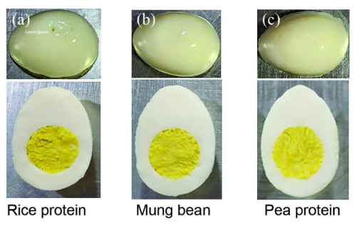

Figure x Visual comparison of whole and halved plant-based hard-boiled eggs prepared using different protein sources: (a) rice, (b) mung bean, (c) pea.

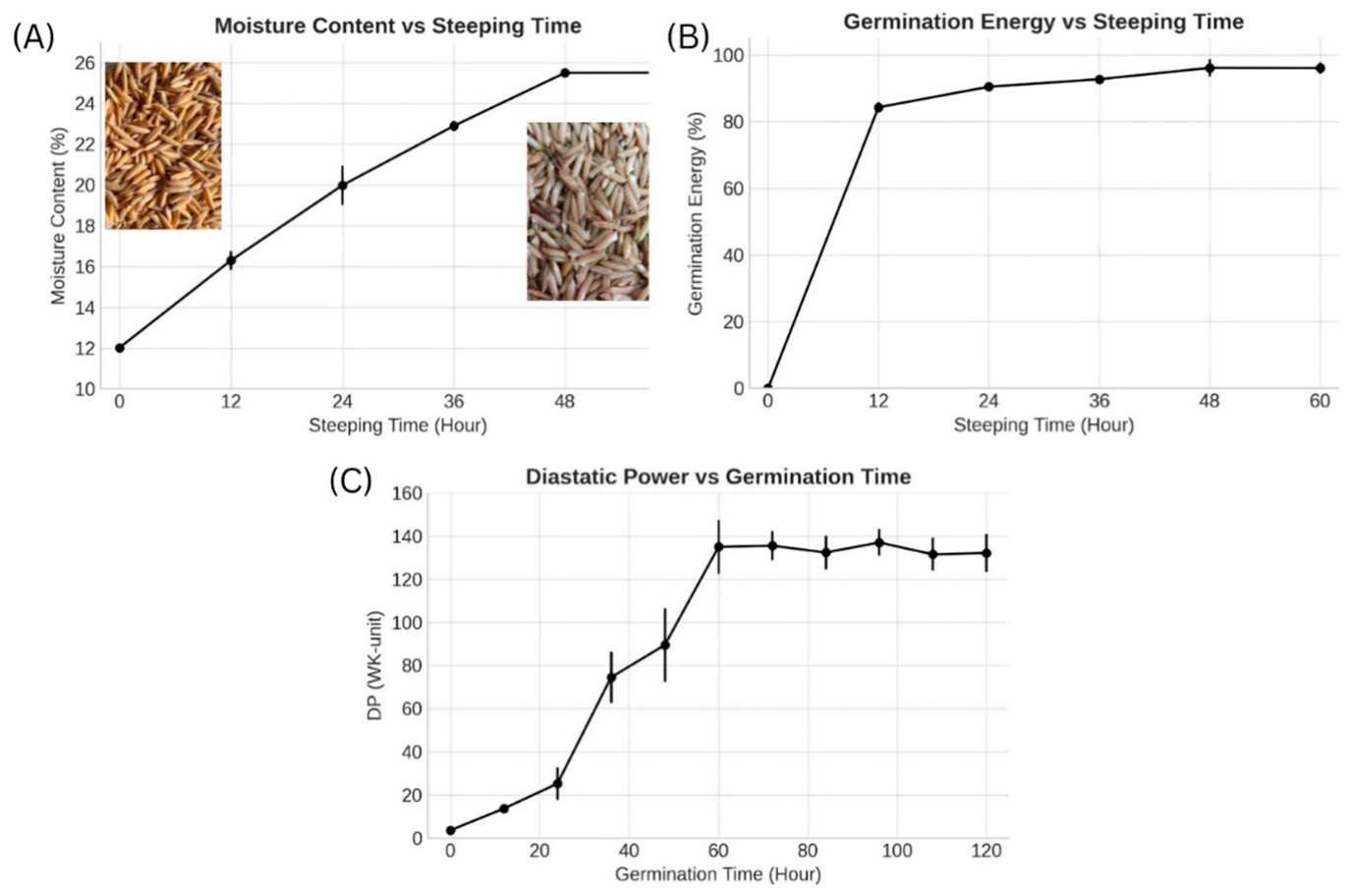

Figure Y Changes in (A) moisture content (%), (B) germination energy (%), and (C) diastatic power (WK units) of Chainat 1 rice during the 120-h steeping and germination period (n = 3).

4.2.1 Figure for JCST review publication.
JCST does not accept figures generated directly by AI image-creation tools. Authors must prepare figures using professional graphic or drawing software and submit them as PNG or JPG files with sufficient resolution (at least 300 dpi). All text, labels, legends, and symbols in the figures must be clearly readable and large enough for publication. Figures generated by AI often contain small, distorted, or unclear text, and may use colored text boxes that reduce readability. For flow-process diagrams, JCST recommends using clear white text boxes with colored outlines or strokes to distinguish different groups or stages.
- Ethical Declaration for Figures
Authors must clearly declare the origin of every figure used in the manuscript. The declaration should be placed beneath the figure caption. The appropriate statement depends on how the figure was prepared.
- Original figure created by the authors
Use this statement when the figure was fully drawn, photographed, or created by the authors.
Figure X. [Caption]. Drawn by the authors.
or
Figure X. [Caption]. Photograph taken by the authors.
- Figure reproduced without modification
Use this statement when the authors use the original figure exactly as published elsewhere. Permission from the copyright holder is required unless the figure is under an open license that allows reuse.
Figure X. [Caption]. Reproduced from [Author, Year] with permission from [copyright holder/publisher].
or
Figure X. [Caption]. Reproduced from [Author, Year] under the terms of the [license name, e.g., Creative Commons Attribution License].
c) Figure adapted or modified from a published source
Use this statement when the authors redraw, modify, simplify, translate, combine, or reorganize a figure based on a previous publication.
Figure X. [Caption]. Adapted from [Author, Year] with permission from [copyright holder/publisher].
or, if allowed by open license:
Figure X. [Caption]. Adapted from [Author, Year] under the terms of the [license name].
d) Figure redrawn by the authors based on published information
Use this statement when the authors do not copy the original figure but create a new figure based on concepts, data, or descriptions from published sources.
Figure X. [Caption]. Redrawn by the authors based on information from [Author, Year].
e) Figure created using the authors’ own data
Use this statement for graphs, charts, diagrams, or models generated from the authors’ research data.
Figure X. [Caption]. Created by the authors based on the data obtained in this study.
f) Figure drawn by the authors with AI assistance
Use this statement only when AI was used to assist with layout, style, or preliminary visual design, but the final scientific content, labels, and accuracy were checked and edited by the authors. AI-generated text, unclear labels, or distorted scientific elements are not acceptable.
Figure X. [Caption]. Drawn and finalized by the authors with the assistance of AI-based design tools. The authors verified and edited all scientific content, labels, and visual elements.
g) Figure generated directly by AI
JCST does not accept figures generated directly by AI image-creation tools without professional redrawing, verification, and correction by the authors. Figures must be scientifically accurate, readable, and suitable for publication.
g) Figure from a public domain or government source
Use this statement when the figure is from a public domain source.
Figure X. [Caption]. Reproduced from [source/organization], public domain.
h) Composite figure using multiple sources
Use this statement when one figure combines several panels or elements from different sources.
Figure X. [Caption]. Panels A and B were drawn by the authors; Panel C was adapted from [Author, Year] with permission from [copyright holder/publisher].

5. Discussion
The discussion should spell out the major conclusions of the work along with some explanation or speculation on the significance of these conclusions. How do the conclusions affect the existing assumptions and models in the field? How can future research build on these observations? What are the key experiments that must be done? The discussion should be concise and tightly argued. Conclusions firmly established by the presented data, hypotheses supported by the presented data, and speculations suggested by the presented data should be clearly identified as such. The results and discussion may be combined into one section, if desired.
6. Limitation
The limitations section should clearly explain the weaknesses or boundaries of the review. Authors should describe factors that may affect the completeness, interpretation, or generalizability of the findings, such as limited databases, restricted publication years, language restrictions, exclusion of unpublished studies, variation in study designs, inconsistent methods, or limited quality of available evidence. The limitations should be stated honestly but concisely, and should be linked to recommendations for future research.
7. Conclusion
The Conclusion section restates the major findings and suggests further research. This parts should be expressed the success of the finding which correspond to the objectives. Moreover, the authors can express the suggestions for the further work here.

8. Acknowledgements
People who contributed to the work but do not fit criteria for authorship should be listed in the Acknowledgments, along with their contributions. It is the authors’ responsibility to ensure that anyone named in the acknowledgments agrees to being so named. The funding sources that have supported the work should be included in the acknowledgments.

9. Abbreviations
Abbreviation | Full Term
AAS | Atomic Absorption Spectroscopy
ANN | Artificial Neural Network
CNN | Convolutional Neural Network
Cu²⁺ | Copper Ion
HPLC | High-Performance Liquid Chromatography
HSV | Hue, Saturation, Value
ICP-MS | Inductively Coupled Plasma Mass Spectrometry

10. CRediT Statement
Example of CRediT Statement
Author name: Conceptualization, Methodology, Writing – Original Draft, Supervision, Funding Acquisition.
Author name: Investigation, Data Curation, Formal Analysis, Visualization, Writing – Review & Editing.
Author name: Resources, Validation, Laboratory Experiments, Data Curation.
Author name: Software, Statistical Analysis, Writing – Review & Editing, Project Administration.

Guide for writing “CRediT Roles”
- Conceptualization:Ideas; formulation or evolution of overarching research goals and aims
- Methodology:Development or design of methodology; creation of models
- Software:Programming, software development, designing computer programs
- Validation:Verification, validation, and reproducibility of results
- Formal Analysis:Statistical, mathematical, or computational techniques
- Investigation:Conducting the research and investigation process
- Resources:Provision of study materials, instrumentation, or other analysis tools
- Data Curation:Management activities to annotate, clean, and maintain data
- Writing – Original Draft:Preparation, creation, and presentation of the published work
- Writing – Review & Editing:Critical review, commentary, and revision
- Visualization:Preparation and presentation of data in graphical forms
- Supervision:Oversight and leadership responsibility for the research activity
- Project Administration:Management and coordination responsibility
- Funding Acquisition:Acquisition of financial support for the project
Please specify each author’s role(s) accordingly.

10. References (Please note that left alignment is used for the References section.)
JCST take seriously for the consistency of the reference list. All reference must be in the same pattern. The author must concern on the one space after punctuations such as full stop (.), comma (,), colon (:), semi colon (;), question mark (?). References are arranged alphabetically according to the last names of the authors and then chronologically. The first line of each reference is aligned left. Use hanging style of 0.5 inch after the first line of each reference. Include the Digital Object Identifier (DOI), (no period at the end).

Please read more details with examples at Style and Grammar Guidelines (apa.org) https://apastyle.apa.org/style-grammar-guidelines
or,
https://libraryguides.vu.edu.au/apa-referencing/7GettingStarted#:~:text=APA%207th%20is%20an%20'author,Use%20round%20brackets.

Journal Articles (Articles with page number & with article number)
Author./(Year of publication)./Article Title./ Full name of Journal Title,/ Volume(Issue),/Page numbers. doi (must be provided)
Example: (From APA)

Ruxton, C. (2016). Tea: Hydration and other health benefits. Primary Health Care, 26(8), 34-42. https://doi.org/10.7748/phc.2016.e1162
Neville, F. G., Drury, J., Reicher, S. D., Choudhury, S., Stott., C., Ball, R., & Richardson, D. (2020). Self-categorization as basis of behavioral mimicry: Experiments in The Hive. PLoS ONE, 15(10), Article e0241227. https://doi.org/10.1371/journal.pone.0241227

Books
Author./(Year of publication)./Book Title./Edition (if any)./Place of publication, Country:/Publisher.
Example: (APA (7th edition) Citation Guide - LibGuides at NWACC Library)

George, M. W. (2008). The elements of library research: What every student needs to know. Princeton University Press.
Samanez-Larkin, G. R. (Ed.). (2019). The aging brain: Functional adaptation across adulthood. American Psychological Association. https://doi.org/10.1037/0000143-000
Johnson, C. L., & Tuite, C. (Eds.). (2009). A companion to Jane Austen. Wiley-Blackwell.
Rottenberg, A. T. (2003). Elements of argument: A text and reader (7th ed.). Bedford/St. Martin's.

Book Articles
Author./(Year of publication)./Article Title./Book Title (Page Numbers)./Edition (if any)./Place of publication, Country:/Publisher.
Example: (APA (7th edition) Citation Guide - LibGuides at NWACC Library)

Shephered, S. (1988). Shakespeare's private drawer: Shakespeare and homosexuality. In G. Holderness (Ed.), The Shakespeare myth (pp. 96–110). Manchester University Press.

Conference and Seminar Proceedings
To cite proceedings that are published regularly, use the same format as for a journal article. To cite proceedings that are published in book form, use the same format as for an article in a book.
Author./(Year, date of conference)./Article Title [Conference presentation]./ Name of the conference, location./Link of the paper or the conference.
Example (The example are given from Conference presentation references (apa.org))
Evans, A. C., Jr., Garbarino, J., Bocanegra, E., Kinscherff, R. T., & Márquez-Greene, N. (2019). Gun violence: An event on the power of community [Conference presentation]. APA 2019 Convention, Chicago, IL, United States. https://convention.apa.org/2019-video
Cacioppo, S. (2019). Evolutionary theory of social connections: Past, present, and future [Conference presentation]. Ninety-ninth annual convention of the Western Psychological Association, Pasadena, CA, United States. https://westernpsych.org/wp-content/uploads/2019/04/WPA-Program-2019-Final-2.pdf

Dissertation or Thesis
Author./(Year of publication)./Title of dissertation or thesis./[Type of Thesis]./Awarding Institution, Country.

Ames, J. H., & Doughty, L. H. (1911). The proposed plans for the Iowa State College athletic field including the design of a reinforced concrete grandstand and wall [Unpublished Master thesis]. Iowa State University, US.
Axford, J. C. (2007). What constitutes success in Pacific Island community conserved areas? [Master Thesis]. University of Queensland. UQ eSpace. http://espace.library.uq.edu.au/view/UQ:158747
Leigh, J. (2010). Self-determined mindfulness and attachment style in college students [Doctoral dissertation]. Indiana State University. ProQuest Dissertations and Theses Global.

Websites
Author./(Year of publication)./Article Title./Retrieved mm dd, year, from the full URL of the web page

Slat, B. (2019). Whales likely impacted by Great Pacific garbage patch. The Ocean Cleanup. Retrieved March 8, 2022, https://www.theoceancleanup.com/updates/whales-likely-impacted-by-great-pacific-garbage-patch
Scribbr. (n.d.). Citing sources in academic writing. Retrieved March 4, 2021, from https://www.scribbr.com/category/citing-sources/

